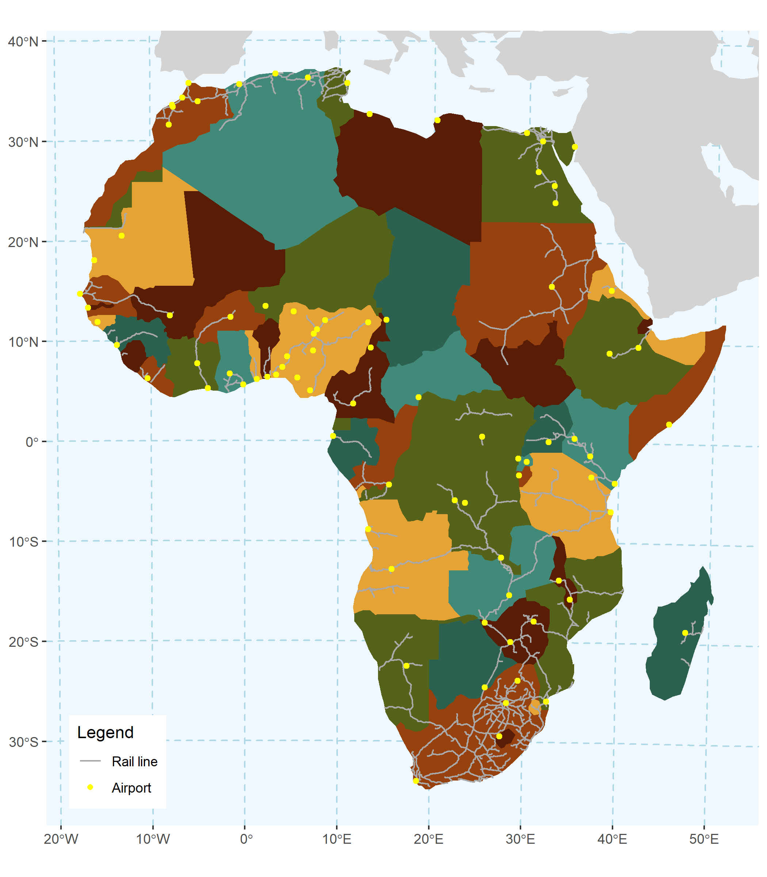

*My classmate,* ***Tianyu Su****, was very helpful to me in completing this assignment. He helped me figure out how to show adjacent land masses on the map while keeping the map extents centered on Africa.*

Data source: Natural Earth (<https://www.naturalearthdata.com/)>

**Transportation Infrastructure in Africa**

This map is intended to show the distribution of rail and airport infrastructure across the African continent. It shows a dense rail network in and around South Africa and a relatively sparse rail network in the rest of the continent. Most, but not all, airports on the continent are shown to be near rail lines.

The intended audience for this map will already know where Africa is located, but may have minimal knowledge of its geography.